**THE GREATEST MAZE**

* **Information you need to play the game.**

**How to start the game:**

You need to open a terminal(linux) where the game’s archives are stored, then use the command ‘make’ to compile the game and then, to run it write ‘./ocabas data1.dat’ and the game will show up like is shown in these pictures:

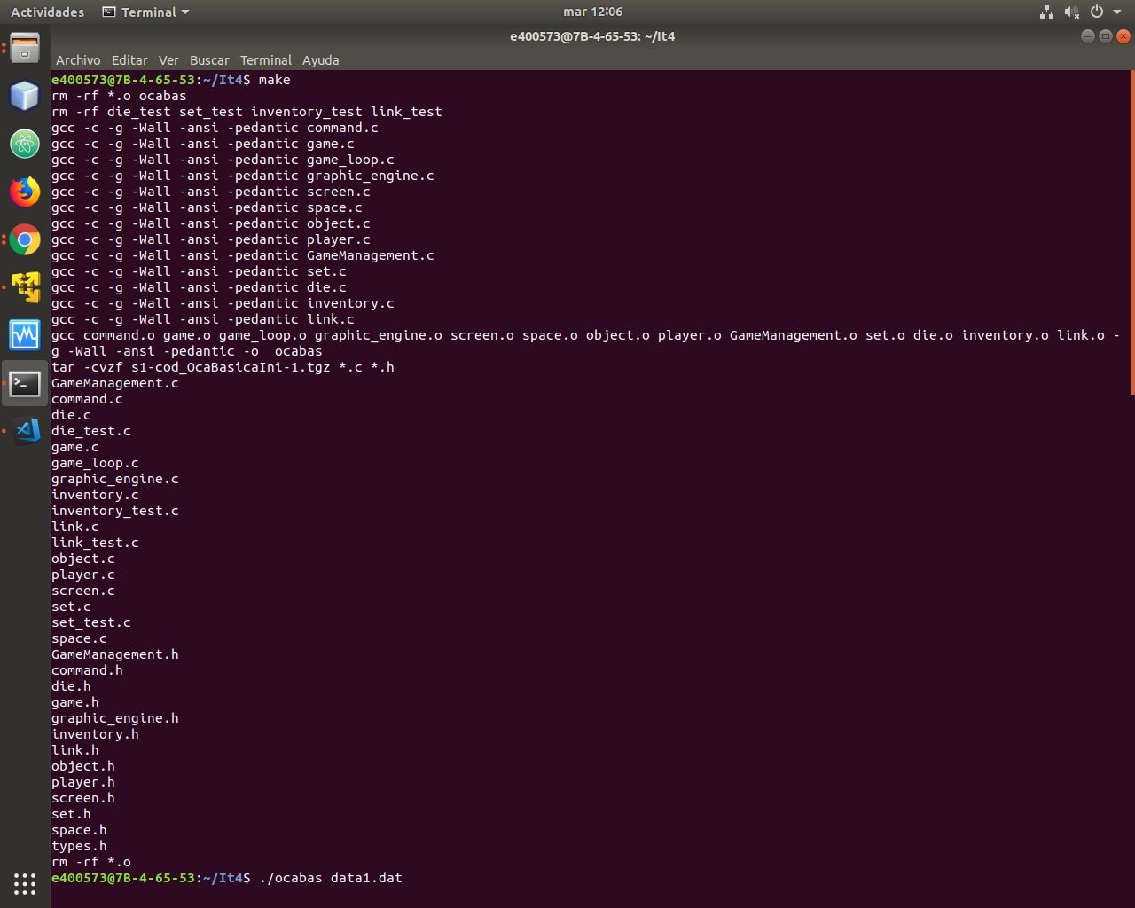

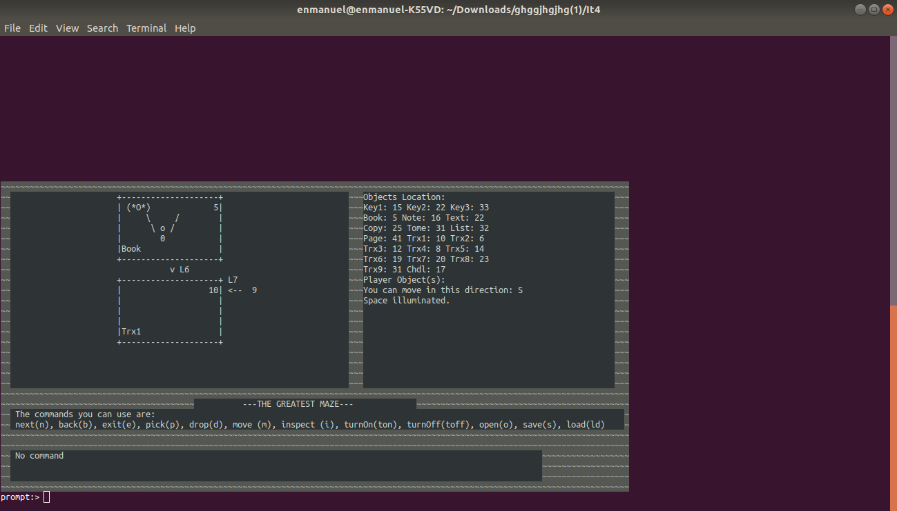

You will start in the space 5. From this, you will need to try to get to the space 42. You will also have some books along the way that will help you to find the end of the trail (try to inspect them). But basically, you must find all the keys hidden along the board. It will also be useful to have some light with you.

A week ago, a terrible earthquake occurred and on the first floor, there was a flood and the torches don’t light as they used to. So maybe you need some light to illuminate all the way.

It also collapsed some paths and now you will need to try to get out. Hopefully somebody managed to create a map with all the lanes you can follow.

* **Map of the game:**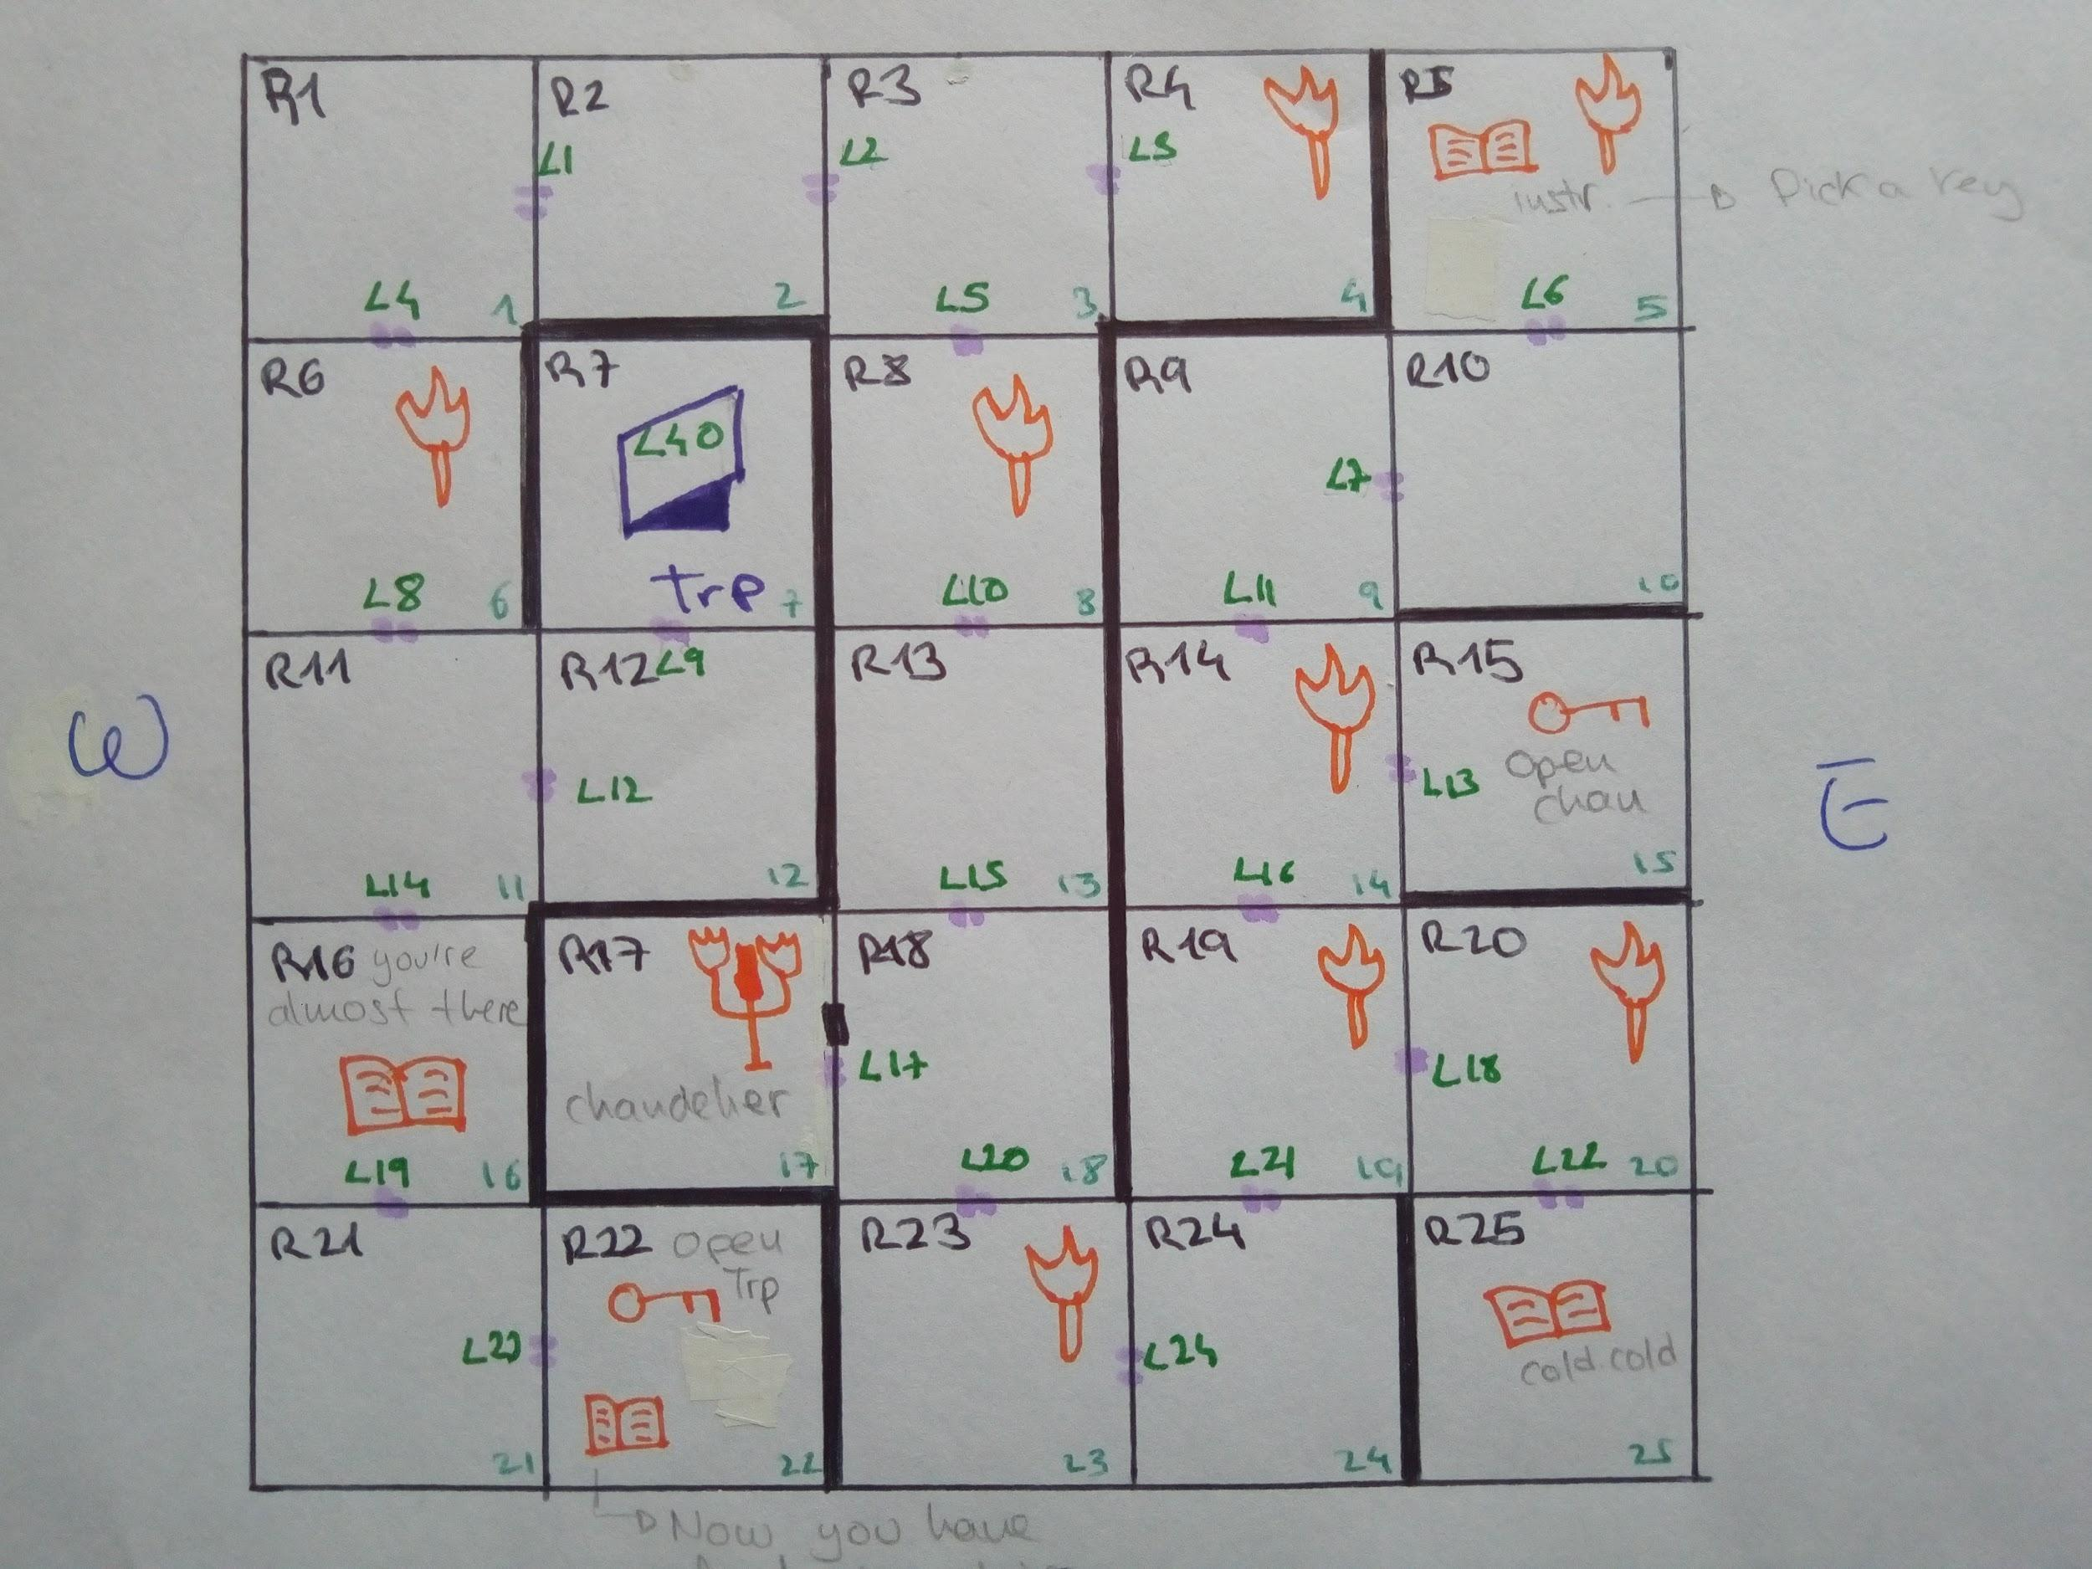

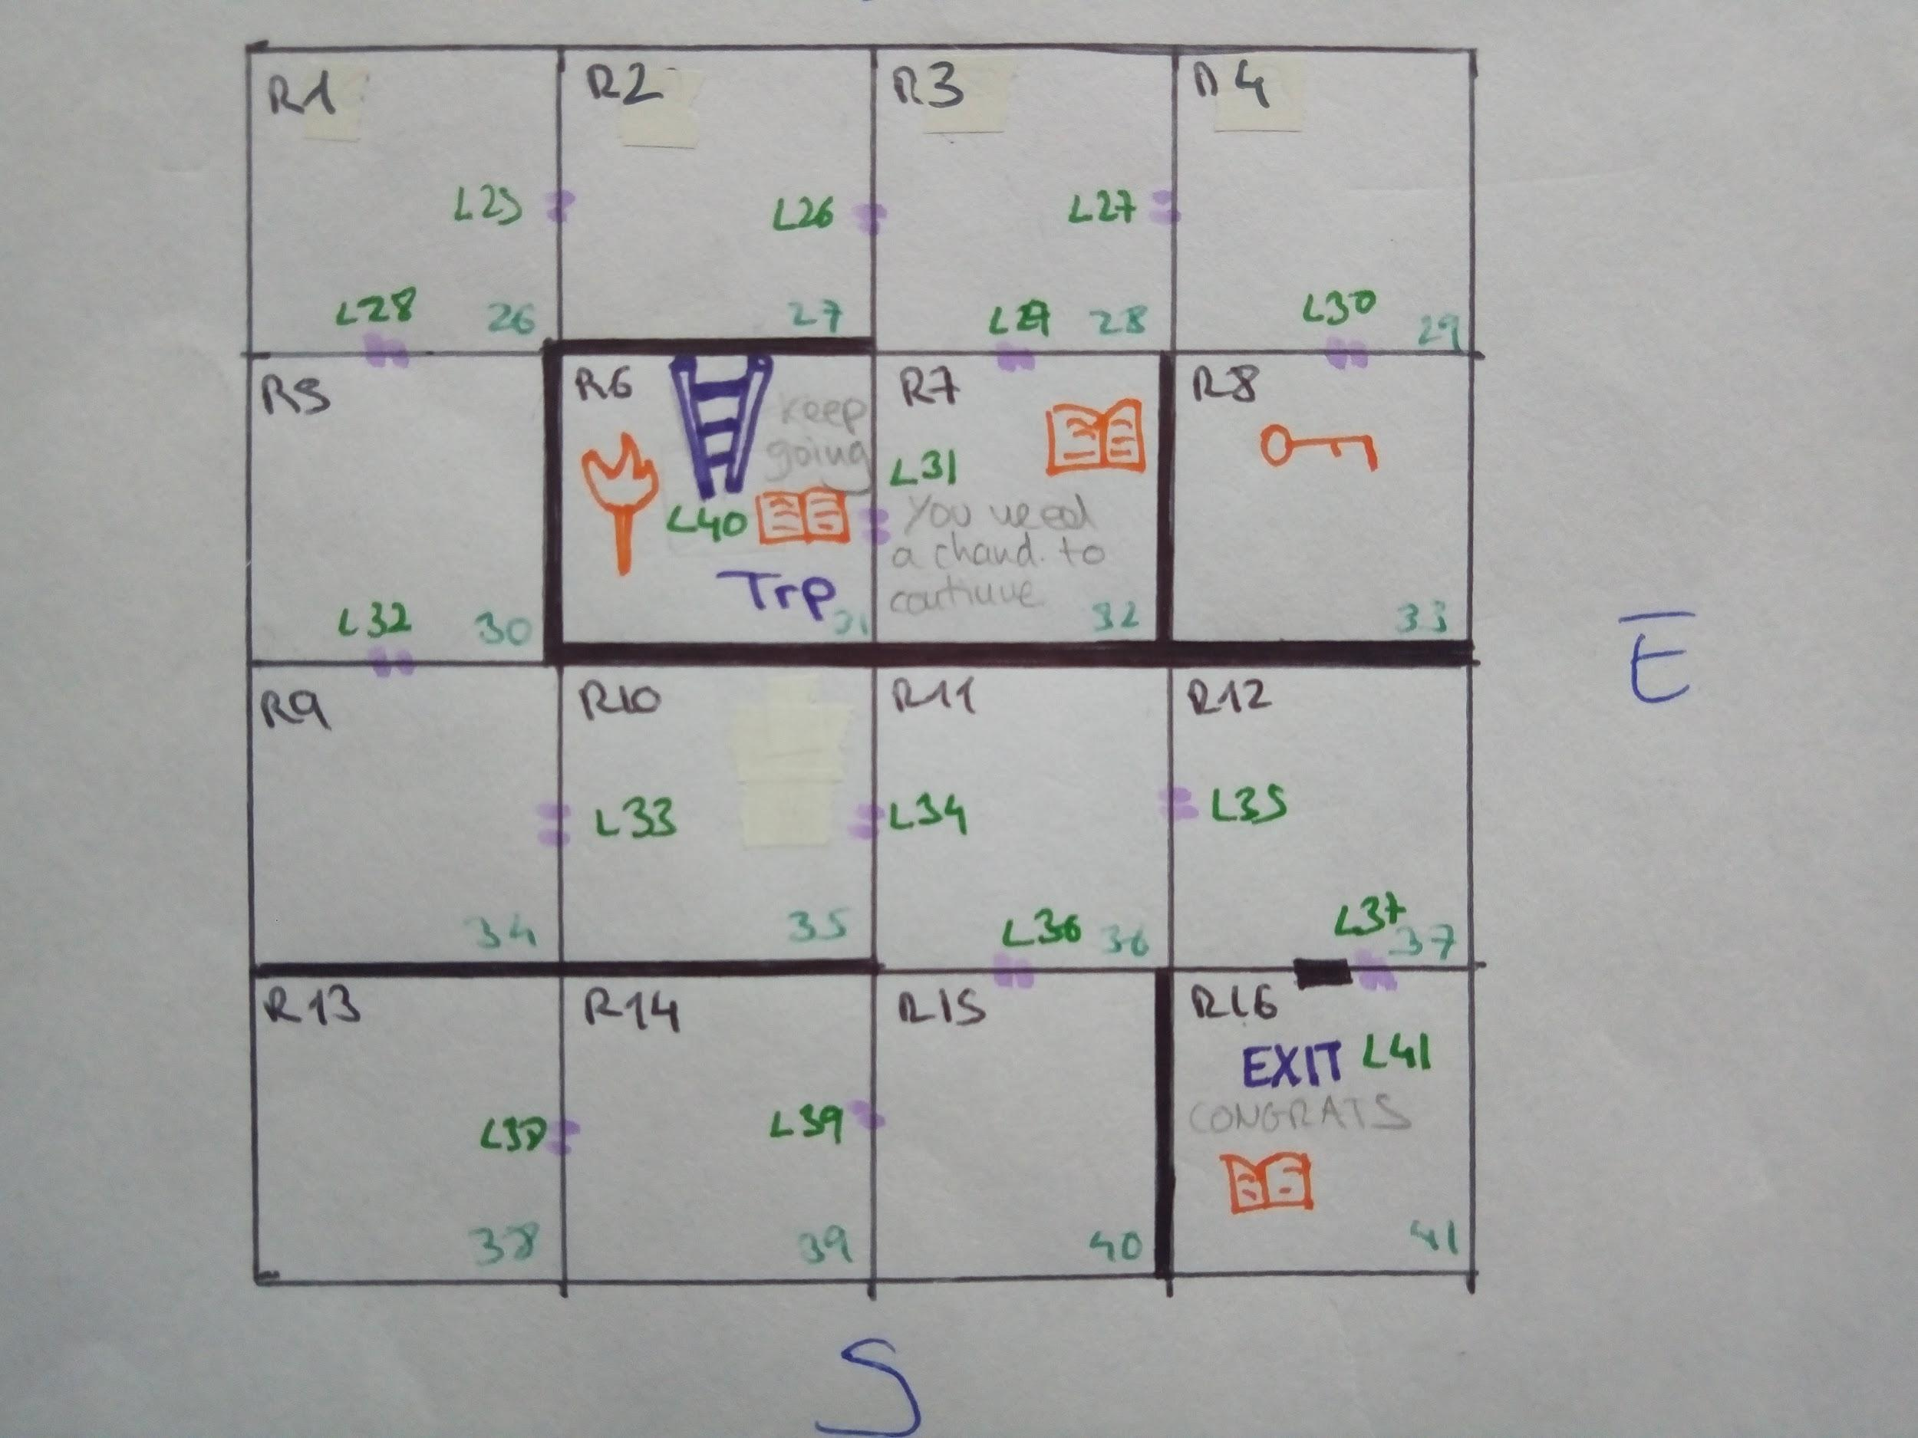

* **How to get to the exit**

From the 5th board box you will need to go south and after that, turn left. If you keep going south, you will find a detour to the right that will lead you to a key that will open a big door with a chandelier inside that will help you light the path. The other torches are fixed, so they will only illuminate their position. You will need to get the space illuminated for being able to inspect the objects and the space itself.

After that you just need to keep following the way and when you find out that you can’t keep going turn east and pick the key to open a hatch near that space.

On the first floor you must find a key to open the door that will lead you to the end of this journey. At the end you will need to jump to some weird vortex that will tele transport you to the winning room. You can save the game whenever you want and load it another time to keep the adventure on.

Enjoy this creepy, naive and simple game!

* **List of commands you can use:**

**m *cardinal point* (m *<n/s/e/w/u/d>*):** move in that direction: north(n), south(s), east(e), west(w), up(u), down(d).

**open <*link>* with <*object>* (o <*link>* with <*obj>*):**opens a link that it’s closed.

**exit (e):** exit the game.

**pick *object* (p <*obj>*):**pick object.

**drop *object* (d <*obj>*)**:drop object.

**inspect *object* (i *<obj>*)**: inspect object.

**inspect space (i <space>)**: inspect space (if it is illuminated).

**Save (s):** save game in a file called *save.txt.*

**Load (ld):** load game from *save.txt.*

**turnOn <*object>* (ton *obj*)**: that object can illuminate.

**turnOff <*object>* (toff *obj*):** that object can not illuminate.